Legend
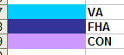

The following excel spreadsheet foreclosure tracking board 2014.xls, illustrates actions that need to be taken after we foreclose.

FHA

*1st legal: date that attorneys posted at the courthouse prior to foreclosure, this info resides in MS
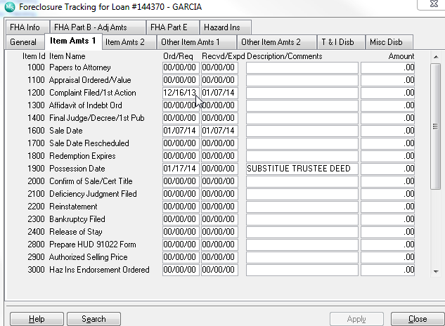
Metric: pick duedate and 1st legal needs to come in 5 months after due date if this is not the case we need to change color or provide an alert that first legal is beyond due date

*UPB:Unpaid Principal Balance, if foreclosre not final we pick the info from the ‘current principal balance” if paid off or foreclosed then we pick amount from “principal paid”

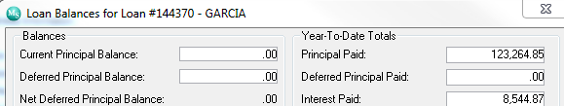

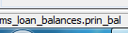
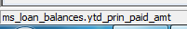

*F/C DATE
Date Foreclosed
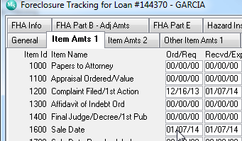
Line 1600 sale date ord/req
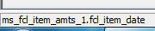

*INSPECTION ORDERED: inspection after foreclosured to see if property is occupy or vacant.

Information will come from memo’s
We are selecting type: pi-conveyance inspection
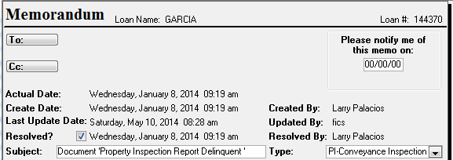

Metric: Inspection needs to be order a day after foreclosure

*Eviction: If prop still occupy we need to vacate property in order for Hud to take over and convey
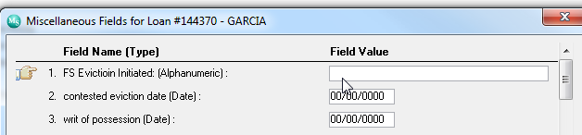
It is a misc field
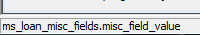

This is the order where we need to populate this date:
- fs eviction initiated misc field

*Writ of possession ordered: court order to tell customer to have borrower vacate property

*Eviction Stop: when we start process and borrower just leaves so we need to stop process of eviction
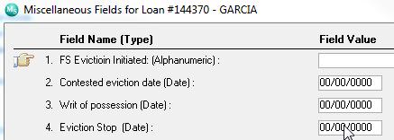

*Eviction Completed:
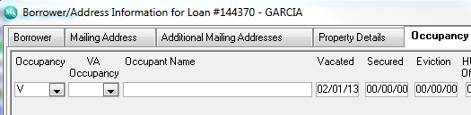
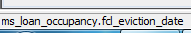

Metric: Eviction completed needs to be 45 or less from foreclosure if not , we need to bring over contested date.

*Conveyance Package Received date
If property is vacant , Russell(property preservation rep) provides the conveyance package ( cleaning of property, lock securing before and after photos, and repairs needed)
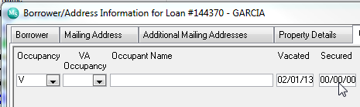
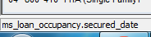

- Possesion Date
The date of foreclose D recorded and or 1st vacancy
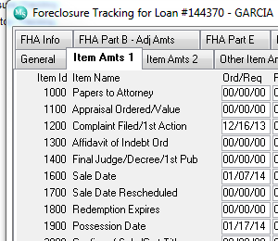
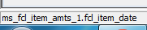
Item 1900 , ord req
*Conveyance (30days from possession)

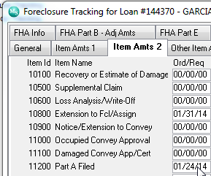
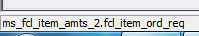
Metric: Possession date + 30 days calendar

*HUD Advice of Payment Part A

When we get paid by hud our conveyance

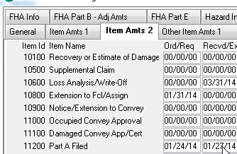

*Payment Amount Part A

The amount we got paid
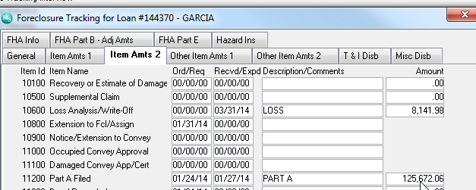

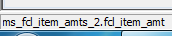

*Title Package
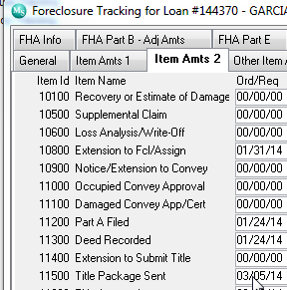

*Title Approval (45 days from Conveyance)
HUD approving the title property and given us okay to do part b
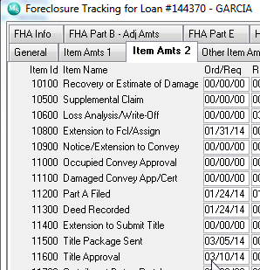

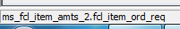

Metric the time from part a filed to title package send needs to be 45 days otherwise we need to have an alert 5 days prior so that foreclosre does not missed date

*Claim

Claim for losses for attorneys fees, eviction , repairs , insurance etc..

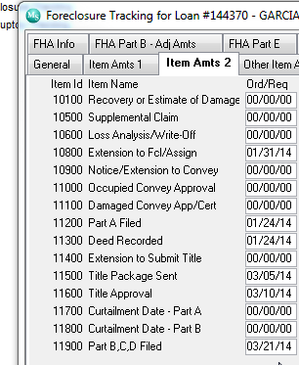

15 days from title approval is this date, again we need to be notified 5 days prior for us to acknowledge and notify

- HUD Advice of payment letter B : Date we got paid

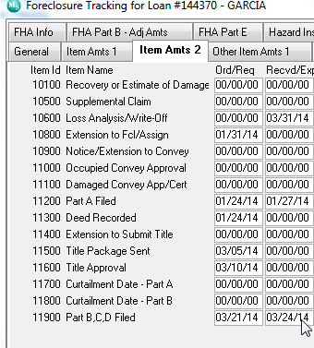
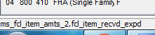

*Claim Payment Amount of part b





